EXPERIMENT – 14

CREATING A DOCKER IMAGE USING DOCKER FILE

1. Check the images which are currently present in your local machine

Command: docker images



1. Create a file named “Dockerfile” in your directory and add the following lines in it.

Command: vim Dockerfile

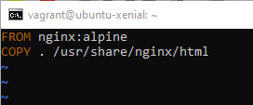

The first line specifies that nginx:alpine will be used a base image for our image.

The second line specifies that contents of the current directory be copied to /usr/share/nginx/html directory.

1. Now create a file named index.html and add a simple line in it.

Command: vim index.html

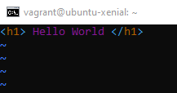

1. Now build the docker file to get the desired image.

Command: docker build –t <image-name> .

Here an image is built in the current directory and tagged with the specified name.

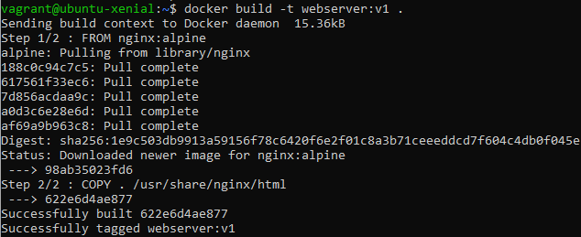

1. Verify the built image

Command: docker images

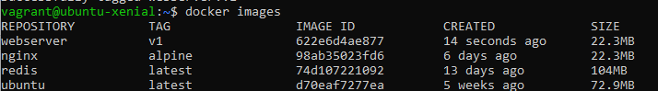

1. Run a container with this image to verify whether image is correctly formed or not.

Command: docker run –d –p 80:80 <image-name>

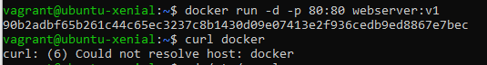

Here image is used to start a container in the background and port 80 of the container is bind to port 80 of the local machine.

1. Let us verify that intended working of the image is being fulfilled.

Command: curl 0.0.0.0:80



1. Now let us push this image to DockerHub. To do that, we have to first login using our docker hub credentials.

Command: docker login –username <docker-hub-username>

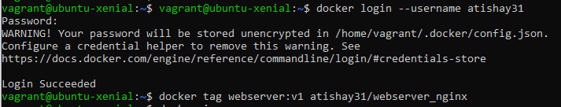

1. Now let us tag the image with a username.

Command: docker tag <image-name> <image-tag>

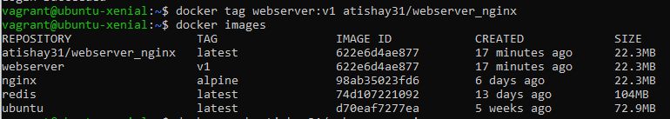

Verify it using docker images command.

1. Push the image to your DockerHub account

Command: docker push <image>

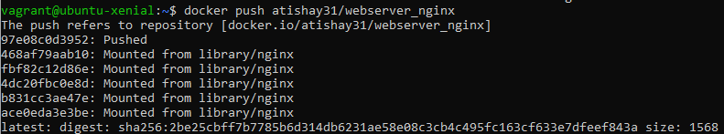

1. Verify the image on your DockerHub account.

